**ASSIGNMENT-2**

**Assignment2.sql:**

use AssignmentDB

-- Create EMP Table

create table EMP (

EMPNO INT PRIMARY KEY,

ENAME VARCHAR(20),

JOB VARCHAR(20),

MGR_ID INT,

HIREDATE DATE,

SAL DECIMAL(7, 2),

COMM DECIMAL(7, 2),

DEPTNO INT,

FOREIGN KEY (DEPTNO) REFERENCES DEPT(DEPTNO)

);

-- Insert data into EMP

insert into EMP values

(7369, 'SMITH', 'CLERK', 7902, '1980-12-17', 800, NULL, 20),

(7499, 'ALLEN', 'SALESMAN', 7698, '1981-02-20', 1600, 300, 30),

(7521, 'WARD', 'SALESMAN', 7698, '1981-02-22', 1250, 500, 30),

(7566, 'JONES', 'MANAGER', 7839, '1981-04-02', 2975, NULL, 20),

(7654, 'MARTIN', 'SALESMAN', 7698, '1981-09-28', 1250, 1400, 30),

(7698, 'BLAKE', 'MANAGER', 7839, '1981-05-01', 2850, NULL, 30),

(7782, 'CLARK', 'MANAGER', 7839, '1981-06-09', 2450, NULL, 10),

(7788, 'SCOTT', 'ANALYST', 7566, '1987-04-19', 3000, NULL, 20),

(7839, 'KING', 'PRESIDENT', NULL, '1981-11-17', 5000, NULL, 10),

(7844, 'TURNER', 'SALESMAN', 7698, '1981-09-08', 1500, 0, 30),

(7876, 'ADAMS', 'CLERK', 7788, '1987-05-23', 1100, NULL, 20),

(7900, 'JAMES', 'CLERK', 7698, '1981-12-03', 950, NULL, 30),

(7902, 'FORD', 'ANALYST', 7566, '1981-12-03', 3000, NULL, 20),

(7934, 'MILLER', 'CLERK', 7782, '1982-01-23', 1300, NULL, 10);

select * from EMP;

-- Create DEPT Table

create table DEPT (

DEPTNO INT PRIMARY KEY,

DNAME VARCHAR(20),

LOC VARCHAR(20)

);

-- Insert data into DEPT

insert into DEPT values

(10, 'ACCOUNTING', 'NEW YORK'),

(20, 'RESEARCH', 'DALLAS'),

(30, 'SALES', 'CHICAGO'),

(40, 'OPERATIONS', 'BOSTON');

select * from DEPT;

-- 1. List all employees whose name begins with 'A'.

select * from EMP where ENAME LIKE 'A%';

-- 2. Select all those employees who don't have a manager.

select * from EMP where MGR_ID IS NULL;

-- 3. List employee name, number and salary for those employees who earn in the range 1200 to 1400.

select ENAME, EMPNO, SAL from EMP where SAL BETWEEN 1200 AND 1400;

-- 4. Give all the employees in the RESEARCH department a 10% pay rise. Verify that this has been done by listing all their details before and after the rise.

-- Before the rise

select * from EMP where DEPTNO = 20;

-- Apply the pay rise

update EMP set SAL = SAL * 1.10 where DEPTNO = 20;

-- After the rise

select * from EMP where DEPTNO = 20;

-- 5. Find the number of CLERKS employed. Give it a descriptive heading.

select COUNT(*) AS NumberOfClerks from EMP where JOB = 'CLERK';

-- 6. Find the average salary for each job type and the number of people employed in each job.

select JOB, AVG(SAL) AS AverageSalary, COUNT(*) AS NumberOfEmployees

from EMP

GROUP BY JOB;

-- 7. List the employees with the lowest and highest salary.

-- Employee with the lowest salary

select * from EMP where SAL = (select MIN(SAL) from EMP);

-- Employee with the highest salary

select * from EMP where SAL = (select MAX(SAL) from EMP);

-- 8. List full details of departments that don't have any employees.

select * from DEPT

where DEPTNO NOT IN (select DISTINCT DEPTNO from EMP);

-- 9. Get the names and salaries of all the analysts earning more than 1200 who are based in department 20. Sort the answer by ascending order of name.

select ENAME, SAL from EMP

where JOB = 'ANALYST' AND SAL > 1200 AND DEPTNO = 20

ORDER BY ENAME ASC;

-- 10. For each department, list its name and number together with the total salary paid to employees in that department.

select D.DEPTNO, D.DNAME, SUM(E.SAL) AS TotalSalary

from DEPT D

LEFT JOIN EMP E ON D.DEPTNO = E.DEPTNO

GROUP BY D.DEPTNO, D.DNAME;

-- 11. Find out salary of both MILLER and SMITH.

select ENAME, SAL from EMP where ENAME IN ('MILLER', 'SMITH');

-- 12. Find out the names of the employees whose name begin with ‘A’ or ‘M’.

select ENAME from EMP where ENAME LIKE 'A%' OR ENAME LIKE 'M%';

-- 13. Compute yearly salary of SMITH.

select ENAME, SAL * 12 AS YearlySalary from EMP where ENAME = 'SMITH';

-- 14. List the name and salary for all employees whose salary is not in the range of 1500 and 2850.

SELECT ENAME, SAL FROM EMP WHERE SAL NOT BETWEEN 1500 AND 2850;

-- 15. Find all managers who have more than 2 employees reporting to them

select MGR_ID, COUNT(*) AS NumberOfEmployees

from EMP where MGR_ID IS NOT NULL

GROUP BY MGR_ID

HAVING COUNT(*) > 2;

**Queries Snapshots:**

Employee Table

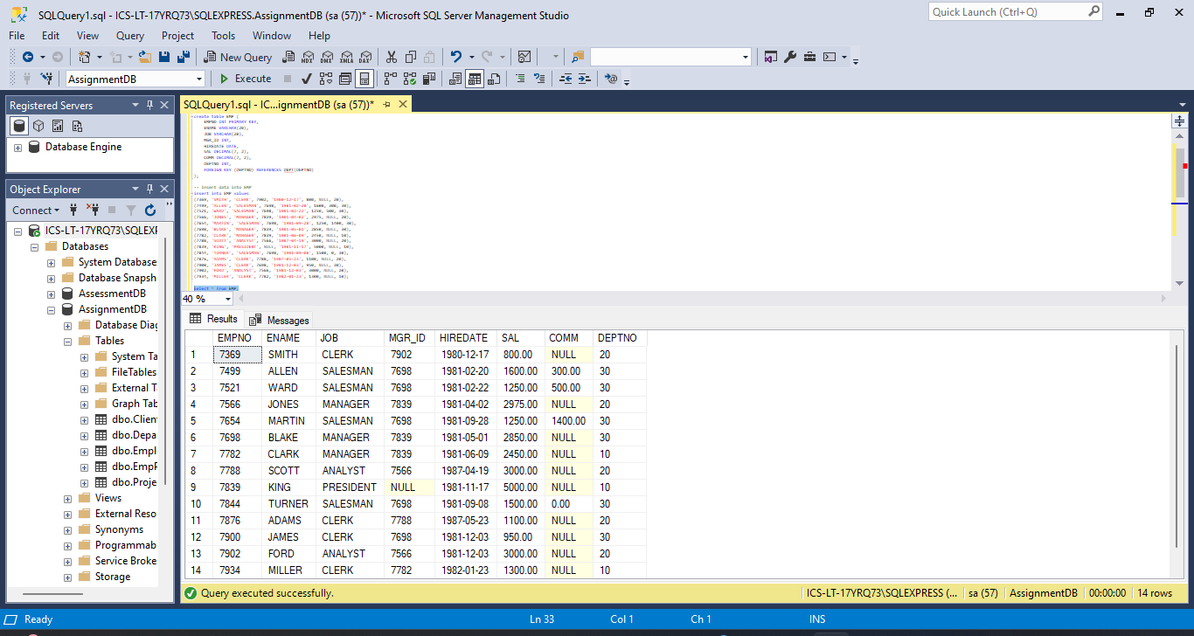

Department Table

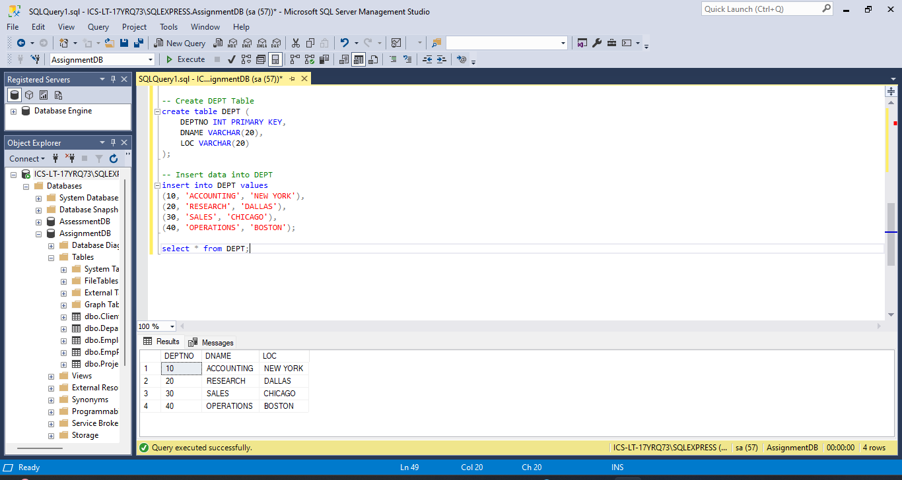

1. List all employees whose name begins with 'A'.

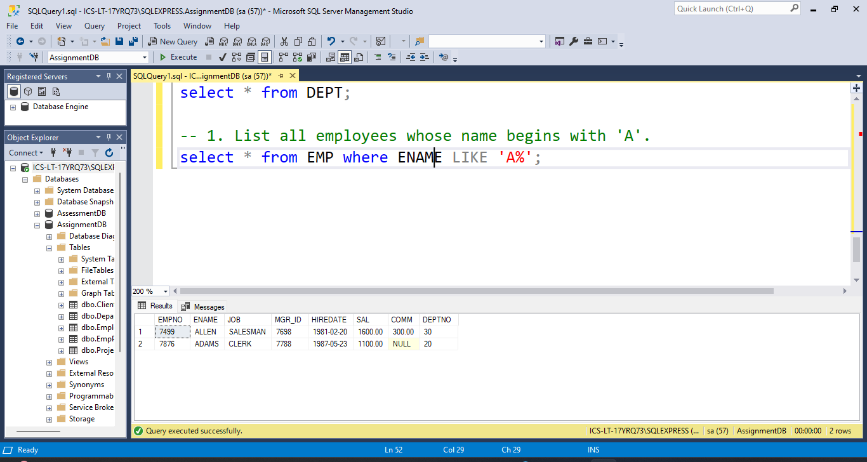

2. Select all those employees who don't have a manager.

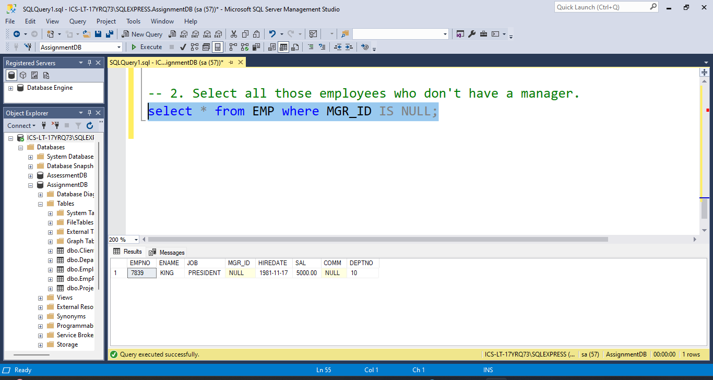

3. List employee name, number and salary for those employees who earn in the range 1200 to 1400.

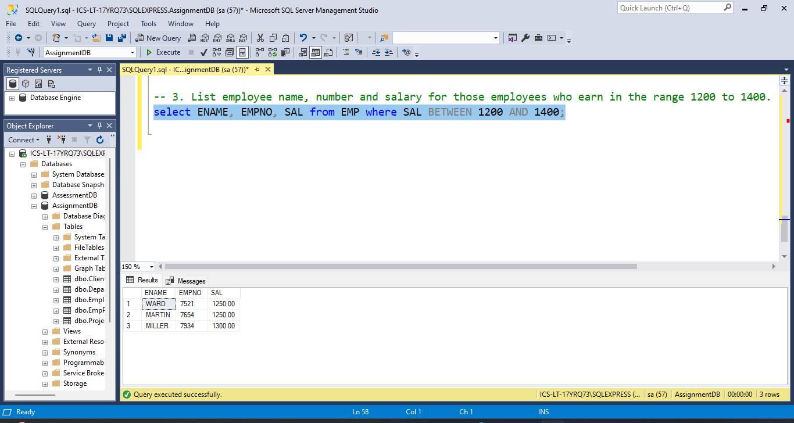

4. Give all the employees in the RESEARCH department a 10% pay rise. Verify that this has been done by listing all their details before and after the rise.

i) Before the rise

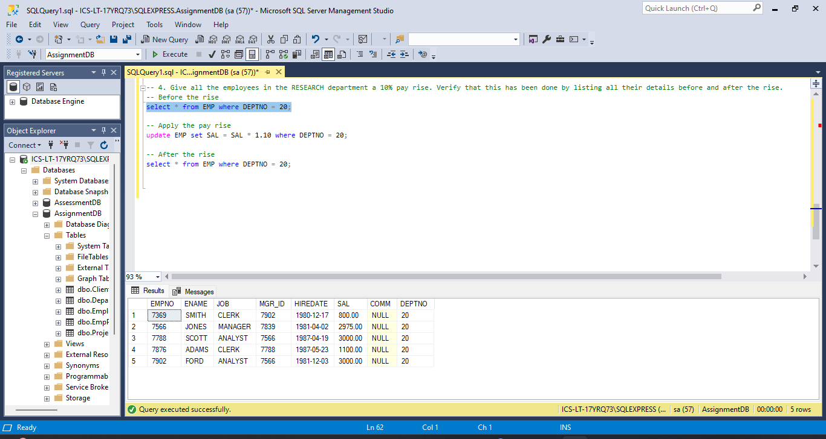

ii) After the rise

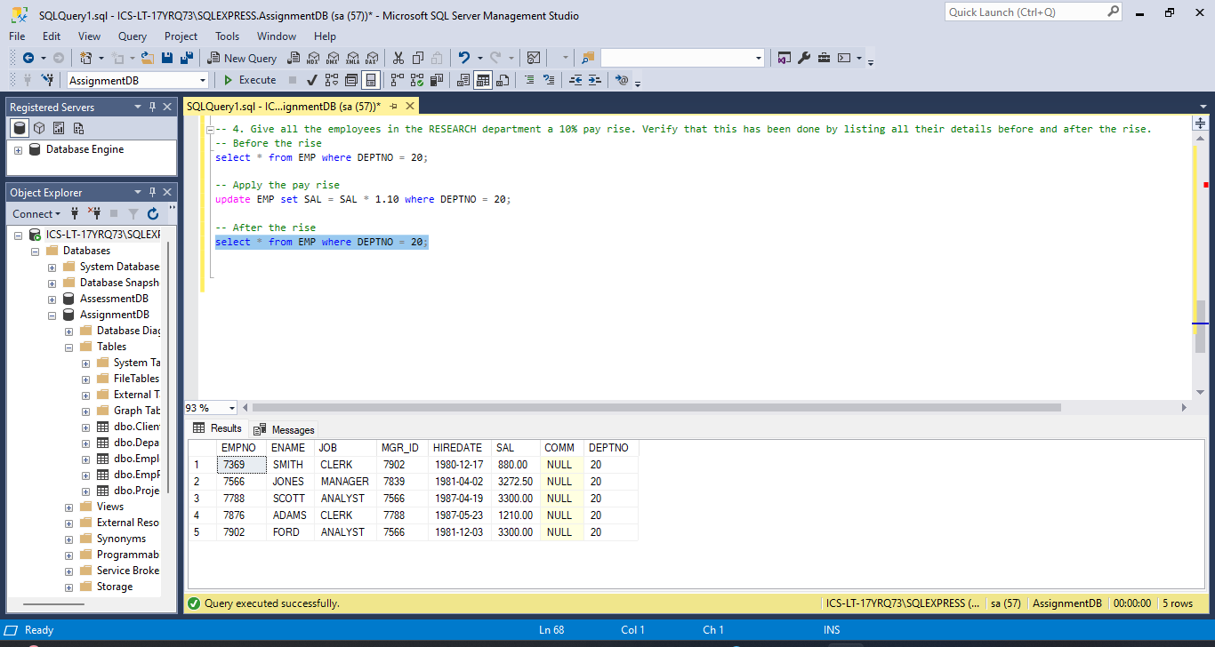

5. Find the number of CLERKS employed. Give it a descriptive heading.

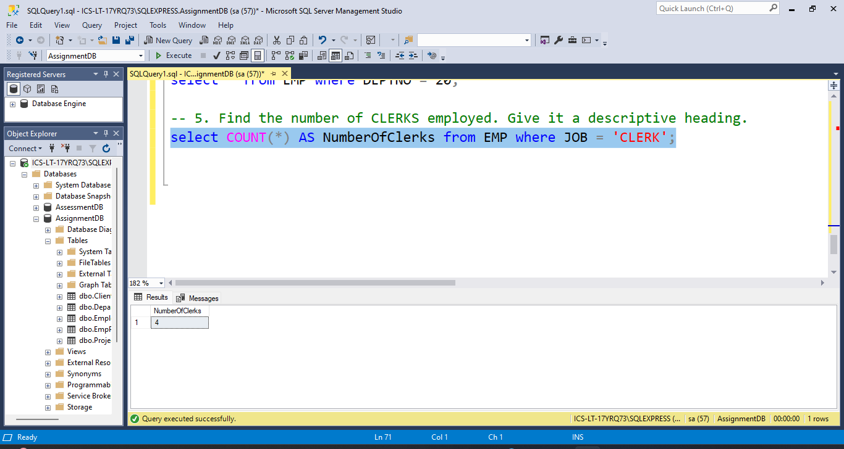

6. Find the average salary for each job type and the number of people employed in each job.

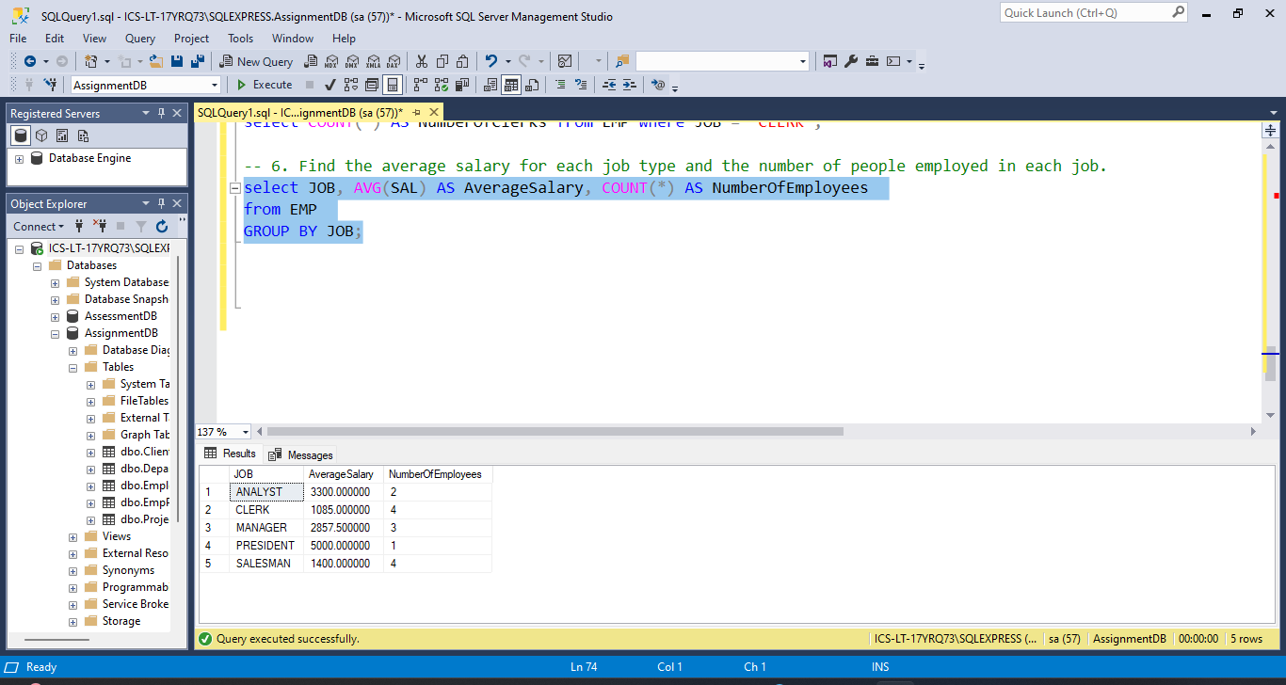

7. List the employees with the lowest and highest salary.

i) Employee with lowest salary

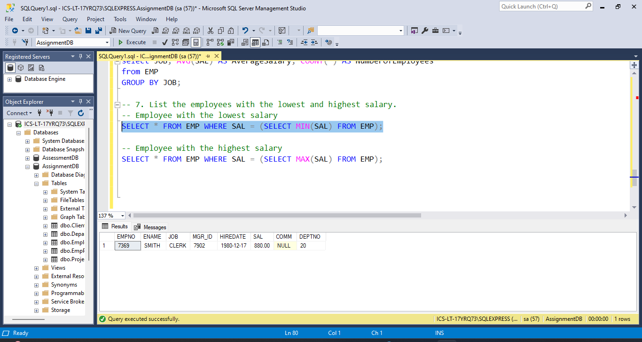

ii) Employee with highest salary

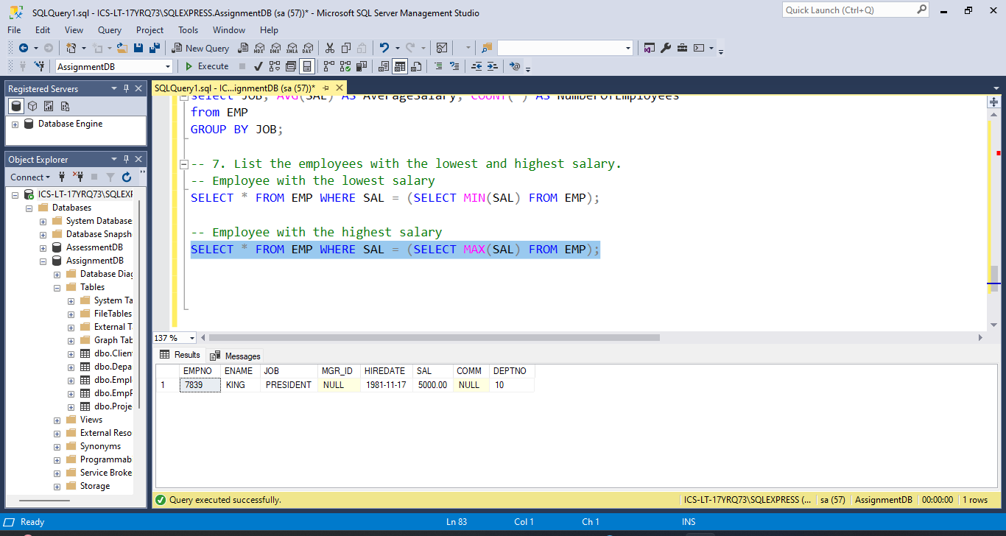

8. List full details of departments that don't have any employees.

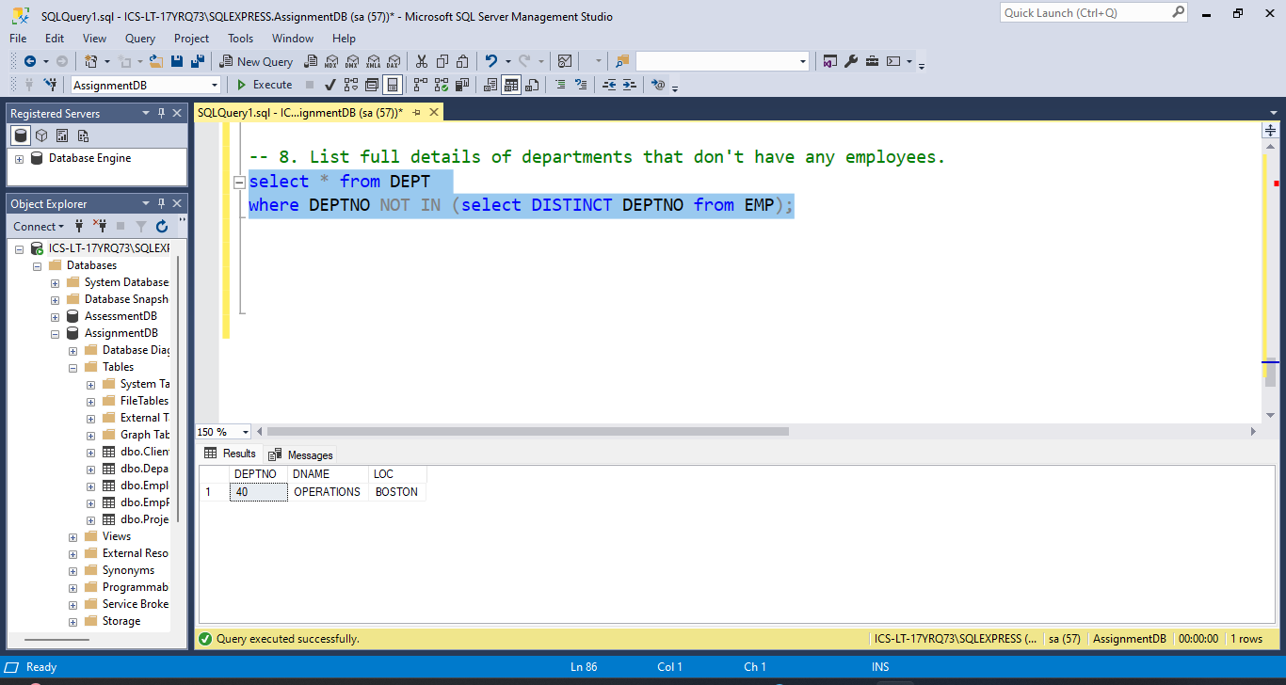

9. Get the names and salaries of all the analysts earning more than 1200 who are based in department 20. Sort the answer by ascending order of name.

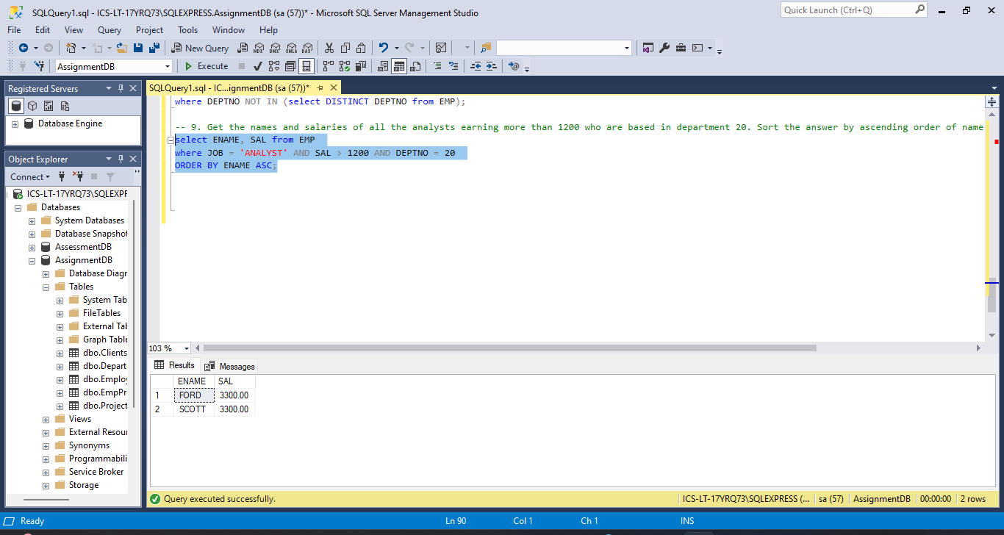

10. For each department, list its name and number together with the total salary paid to employees in that department.

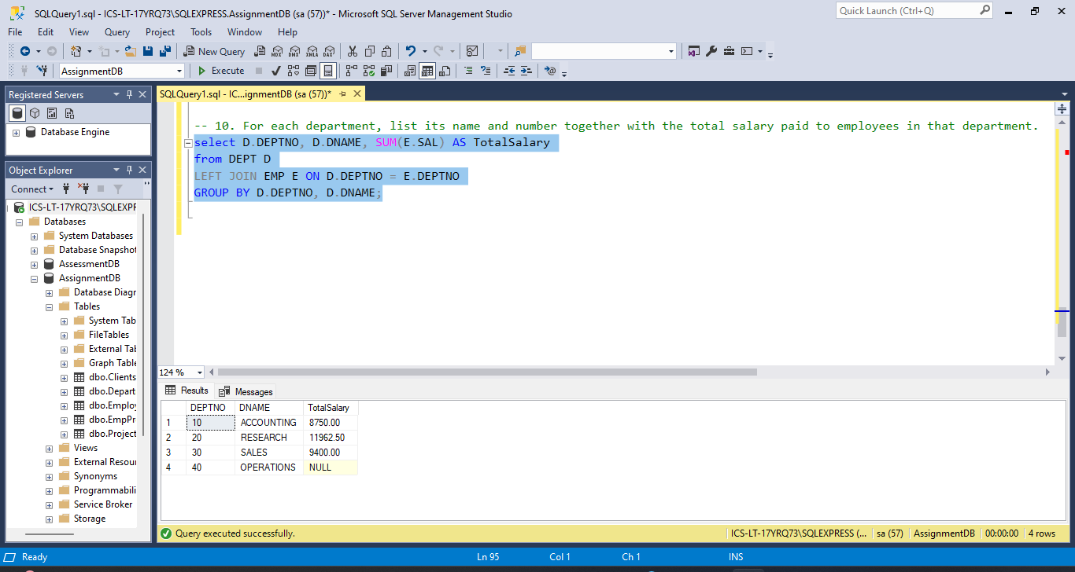

11. Find out salary of both MILLER and SMITH.

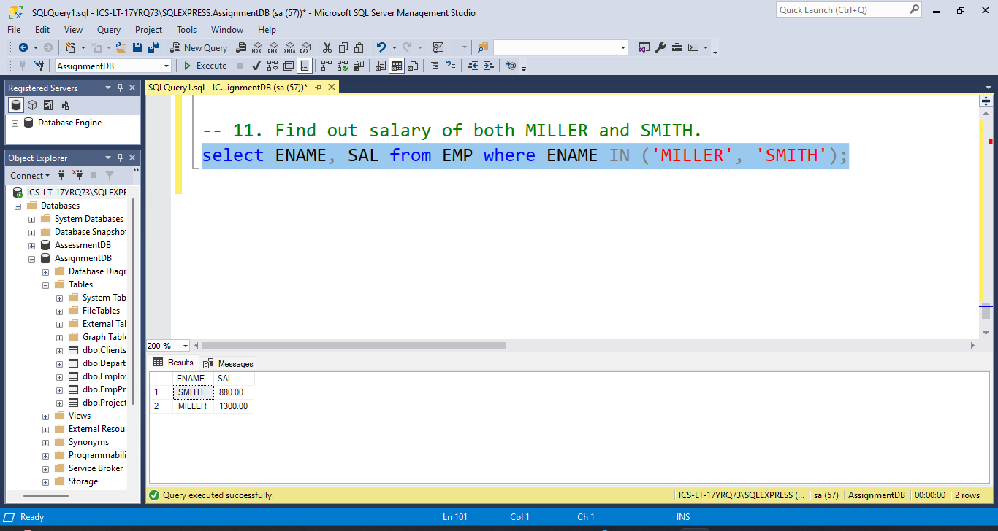

12. Find out the names of the employees whose name begin with ‘A’ or ‘M’.

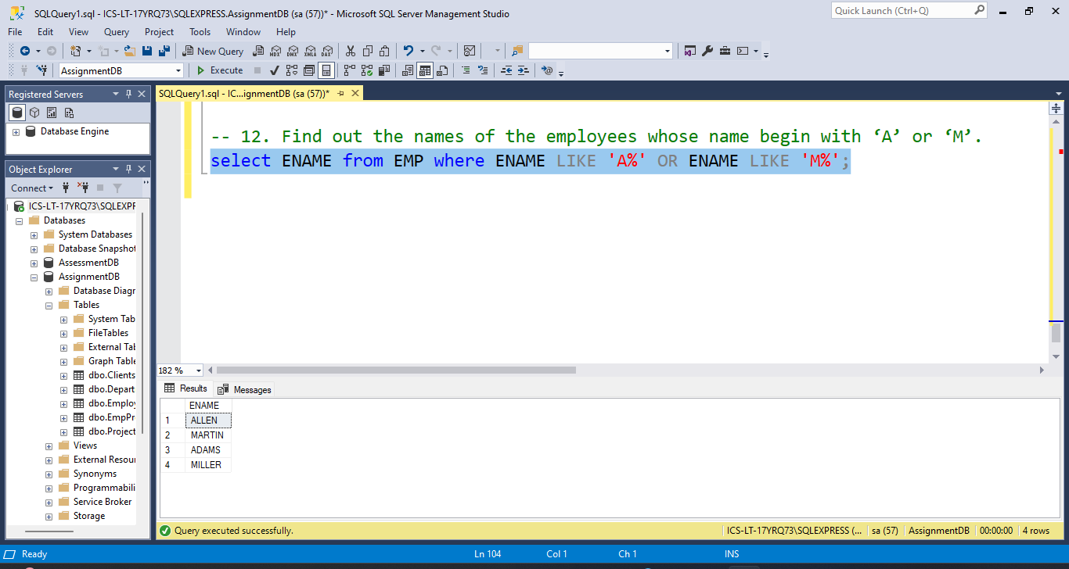

13. Compute yearly salary of SMITH.

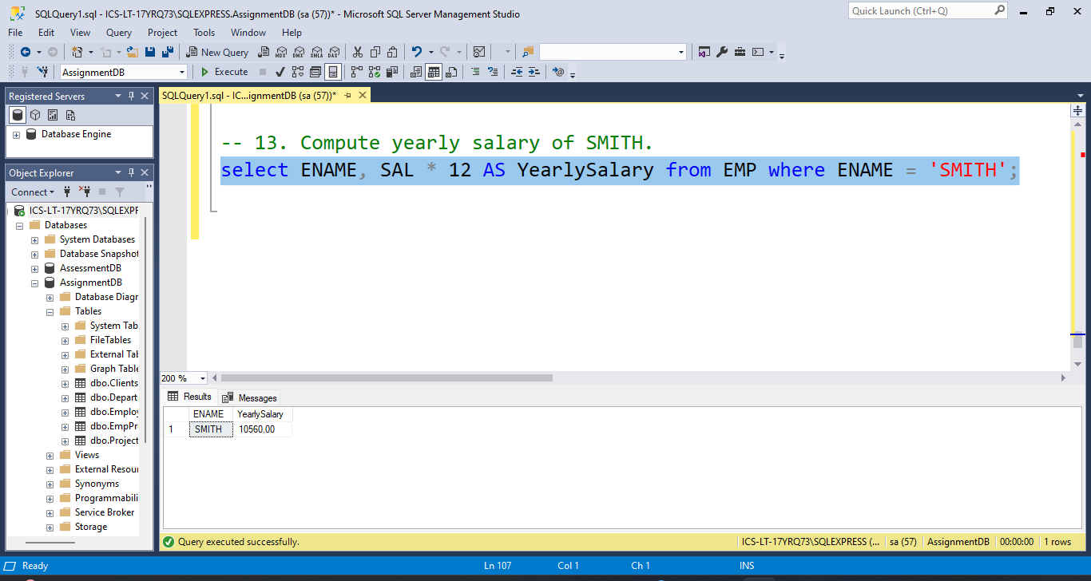

14. List the name and salary for all employees whose salary is not in the range of 1500 and 2850.

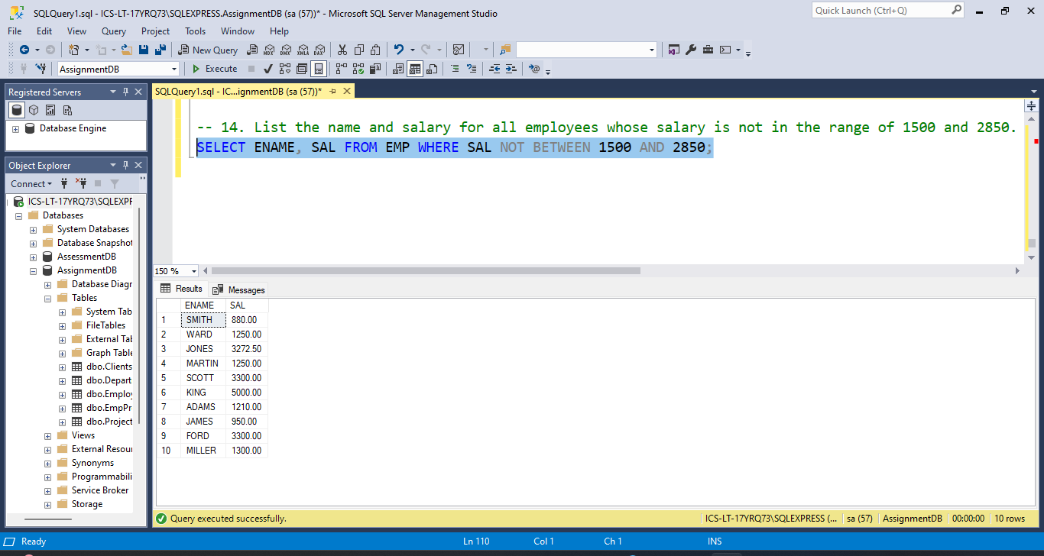

15. Find all managers who have more than 2 employees reporting to them

